COPY RIGHT



**2023 IJIEMR**. Personal use of this material is permitted. Permission from IJIEMR must be obtained for all other uses, in any current or future media, including reprinting/republishing this material for advertising or promotional purposes, creating new collective works, for resale or redistribution to servers or lists, or reuse of any copyrighted component of this work in other works. No Reprint should be done to this paper, all copy right is authenticated to Paper Authors

IJIEMR Transactions, online available on 21st Feb 2023. Link

:[http://www.ijiemr.org/downloads.php?vol=Volume-12&issue=Issue 03](http://www.ijiemr.org/downloads.php?vol=Volume-12&issue=Issue03)

## 10.48047/IJIEMR/V12/ISSUE 03/32

##### Title HUE PRESERVATION BASED HIGH EFFICIENCY UNDER WATER IMAGE CORRELATION AND ENHANCEMENT USING DEEP LEARNING TECHNIQUE

Volume 12, ISSUE 03, Pages: 222-229

Paper Authors

**Bhupathiraju Geetha Supriya, Yogitha Potlapally, Katepogu Stephen Kumar, Jonnadula Narasimharao**

 

USE THIS BARCODE TO ACCESS YOUR ONLINE PAPER

To Secure Your Paper As Per UGC Guidelines We Are Providing A Electronic Bar Code

**HUE PRESERVATION BASED HIGH EFFICIENCY UNDER WATER IMAGE CORRELATION AND ENHANCEMENT USING DEEP LEARNING TECHNIQUE**

##### 1Bhupathiraju Geetha Supriya, 2Yogitha Potlapally, 3Katepogu Stephen Kumar,

**4Jonnadula Narasimharao**

1,2,3 B.Tech Student, Department of Computer Science and Engineering, CMR Technical Campus, Medchal, Hyderabad, Telangana, India

[1197r1a05j9@cmrtc.ac.in,](mailto:1197r1a05j9@cmrtc.ac.in) [2197r1a05q0@cmrtc.ac.in,](mailto:2197r1a05q0@cmrtc.ac.in) [3177r1a05f1@cmrtc.ac.in](mailto:3177r1a05f1@cmrtc.ac.in) 4Assistant Professor, Department of Computer Science and Engineering, CMR Technical Campus, Medchal, Hyderabad, Telangana, India [jonnadula.narasimharao@gmail.com](mailto:jonnadula.narasimharao@gmail.com)

its applications. One such area is enhancement of underwater images [1]. As

**ABSTRACT: Underwater imaging is an emerging area of research. Underwater image processing has played an important role in various fields such as submarine terrain scanning, submarine communication cable laying, underwater vehicles, underwater search and rescue. However, there are many difficulties in the process of acquiring underwater images. Underwater Image suffers from serious color distortion and low contrast problems because of complex light propagation in the ocean. Underwater image capturing is a challenging task due to attenuation of light in water. Scattering and absorption are results of light attenuation which leads to faded colors and reduced contrast of images, respectively. To deal with these issues, to provide better visual quality image and in view of computing constraints of underwater vehicles, Hue preservation based high-efficiency under water image correlation and enhancement using deep-learning Technique is presented. The framework contains three convolutional neural networks for underwater image color restoration. At first, CNN is used to convert the input underwater image into the gray scale image. Next, grayscale underwater image is enhanced by the second CNN and then, the color correction is formed to the input underwater image by the third CNN. At last, color-corrected image is obtained by integrating the outputs of three CNNs based on the hue preservation.**

**KEYWORDS: Underwater image, Hue preservation, Convolutional Neural Network (CNN).**

##### INTRODUCTION

Use of digital images has become inevitable in today’s world. This has areas related to image preprocessing and

the environment of underwater is much more complex than that on land and as there is no source of light in underwater environment, underwater imaging systems have to rely on the artificial light to provide illumination. Underwater imaging is widely used in scientific research and technology such as marine biology and archaeology. Underwater scenario is attracting the scientists, biologists and researchers due to its wide variety of marine animals and fish species, incredible landscape, beautiful coral reefs and mysterious shipwrecks.

The ocean contains abundant resources both in Biology and energy, which is one of the core components for maintaining human’s sustainable development. Obtaining valuable information through images is a necessary means in the process of exploring the ocean. Autonomous underwater vehicles (AUV) are generally used for gathering images and videos from a wide variety of underwater environment like coral reefs, underwater mines, shipwrecks, telecommunication cables, oil and natural gas pipelines [5].

With recent advances in diversified technologies, high-end underwater remotely operated vehicles (ROVs), autonomous underwater vehicles (AUVs), and autonomous underwater robots have been extensively employed for navigation,

exploration, and surveillance in underwater environments. These underwater vehicles and robots are typically equipped with optical sensors for acquiring underwater images. From the perspective of academia and industry, underwater imaging is critical to various applications such as archaeology, mine and wreckage detection, marine biology, water fauna identification and assessment, and offshore wind power turbine basis inspection [6].

Generally, captured underwater images are degraded by scattering and absorption. Scattering means a change of direction of light after collision with suspended particles, which causes the blurring and low contrast of images. Absorption means light absorbed by suspended particles which depends on the wavelength of each light beam. The light with shorter wavelength (i.e., green and blue light) travels longer in water. As a result, underwater images generally have predominantly green-blue hue. Contrast loss and color deviation are main consequences of underwater degradation processes, which bring difficulties to further processing [3].

The existing research shows that underwater images raise new challenges and impose significant problems due to light absorption, light reflection, bending and scattering of light, and poor visibility. Several factors such as selection of a colour model, characteristics of the human visual system, and colour contrast sensitivity must be considered for colour image enhancement. Contrast enhancement, colour correction, and nonuniform lighting improvement of underwater colour images are well-studied problems [4].

Image enhancement is to bring more visibility to the image and make it more

appropriate to the required application. In today’s scenario, the process of underwater image enhancement becomes an important area of study. Image enhancement intensifies the information content of the image by accentuates the deep underwater image edges and changes the visual influence of the observer. The sharpness and contrast of the images captured in underwater suffer from poor color contrast and poor visibility. Moreover, the quality of underwater images deteriorates due to the physical properties of the aquatic medium, light scattering, reflection, and becomes more and less visible as water depth increases.

Images captured under water are often characterized by low contrast, color distortion, and noise, hindering some visual tasks carried out on it. Despite remarkable breakthrough has been made in recent years, effective and robust enhancement of [degraded image](https://www.sciencedirect.com/topics/engineering/degraded-image) remains a challenging problem [2]. Therefore, it is expected to develop an effective method overcome these shortcomings.

To overcome this limitation, deep learning technology is used to estimate the unkown parameters. Recently, several Neural Networks (NNs) have been applied to estimate transmission. These deep learning models are trained with synthetic training set to regress transmission and obtain more refined restorations than conventional methods. Hence in this work, hue preservation based high efficiency under water image correlation and enhancement using deep learning technique. The rest of the work is organized as follows: The section II describes the Literature survey. The section III presents the hue preservation based high efficiency under water image correlation and enhancement using deep learning technique. The section IV evaluates the result analysis of

presented approach. The section V provides the conclusion.

##### LITERATURE SURVEY

Zeba Patel, Chaitra Desai, Ramesh Ashok Tabib, Medha Bhat, Ujwala Patil, Uma Mudengudi et. al., [7] describes Framework for under water image enhancement. The main aim is to balance the color distribution of the underwater image in LAB color space, to remove the bluish green tin caused due to atmospheric light attenuation. Focus is on sharpening the underwater image to enhance the edges distorted during the process of color balance. We emphasize on fusion of outputs obtained after color balancing and edge sharpening. Authors demonstrated the performance of the proposed framework using qualitative evaluation metrics and show, the results obtained through this framework outperforms the state of the art enhancement methods.

Chonyi Li, Jichang Guo, and Chunle Guo et. al., [8] describes Emerging from Water: Underwater Image color correction based on weakly supervised color transfer inspired by Cycle-Consistent Adversarial Net- works, authors designed a multi-term loss function including adversarial loss, cycle consistency loss, and SSIM (Structural Similarity Index Measure) loss. In this way, they translate the color of underwater image as if it is taken in the air, and preserve the content and structure of original underwater image. Experiments on underwater images captured under diverse scenes show that the proposed method can produce visually pleasing results, even outperforms the art-of-the-state methods.

Krishnapriya T S, Dr. Nissan Kunju et. al.,

[9] presents Underwater Image Processing using Hybrid Techniques. Gray world technique is presented for white balance.

From the corrected image, weight maps- based feature extraction would be done followed by multi fusion and image enhancement. Due to the wide application of wavelet transform in image processing, here using two- dimensional Discrete Wavelet Transform as fusion operator. Also, make the synaptic network to the new level of application. The result demonstrates that this enhancement algorithm can obtain a well visual result.

Jie Li, Katherine A. Skinner, Ryan M. Eustice, and Mathew Johnson-Roberson et. al., [10] describes WaterGAN: Unsupervised Generative Network to enable Real-Time color correction of Monocular Underwater Images WaterGAN. They describes a generative adversarial network (GAN) for generating realistic underwater images from in-air image and depth pairings in an unsupervised pipeline used for color correction of monocular underwater images. Using WaterGAN authors generated a large training dataset of corresponding depth, in-air color images, and realistic underwater images. These data serve as input to a two-stage network for color correction of monocular underwater images. Our proposed pipeline is validated with testing on real data collected from both a pure water test tank and from underwater surveys collected in the field. Source code, sample datasets, and pretrained models are made publicly available.

K. Panetta, Chen Gao, and Sos Again et. al., [11] describes Human-visual-system inspired Underwater Image Quality Measures. A new non-reference underwater image quality measure (UIQM) is presented in this analysis. The UIQM comprises three underwater image attribute measures: the underwater image colorfulness measure (UICM), the underwater image sharpness measure

(UISM), and the underwater image contrast measure (UIConM). Each attribute is selected for evaluating one aspect of the underwater image degradation, and each presented attribute measure is inspired by the properties of human visual systems (HVSs). The experimental results demonstrate that the measures effectively evaluate the underwater image quality in accordance with the human perceptions. These measures are also used on the AirAsia 8501 wreckage images to show their importance in practical applications.

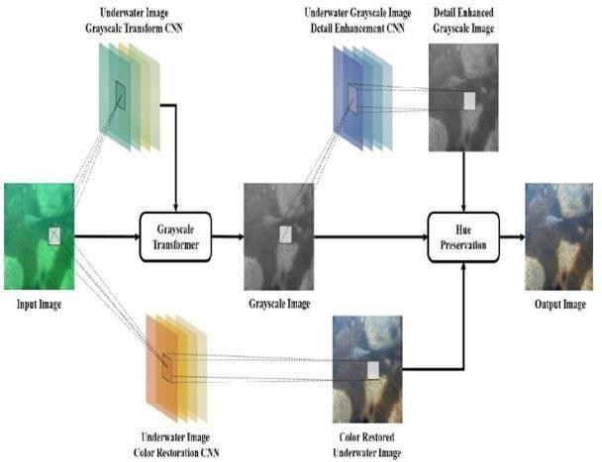

##### HUE PRESERVATION BASED HIGH EFFICIENCY UNDER WATER

**IMAGE CORRELATION AND ENHANCEMENT**

In this section, hue preservation based high efficiency under water image correlation and enhancement using deep learning technique is presented. The architecture of presented approach is shown in Fig. 1. This work is mainly based upon Underwater Image color correction and contrast enhancement based on hue preservation. The underwater image color restoration is the main stage of the framework. End-to-end convolutional neural network is used to correct the color loss in the underwater image. Underwater color correction is a complex problem. A high image quality in-air images have to contain high color saturation, right color balance and appropriate image contrast. Thus a loss function is designed which restricts many conditions for the underwater image color restoration CNN regression.

**Fig. 1: The Architecture of hue preservation based high efficiency under water image correlation and enhancement**

preservation based high efficiency under water image correlation and enhancement using deep learning technique consists of the four phases: (i) the underwater image grayscale stage relying onCNN to convert the underwater image to the best gray- channel image; (ii) the grayscale underwater image details enhancement stage also relying on CNN to remove the noise and enhance the image quality; (iii) the underwater image color restoration stage via end-to-end CNN; and (iv) the generation stage of the final high image quality and correct color underwater image by integrating the outputs of the other three stages.

As shown in Fig. 1, presented hue

A convolutional neural network (CNN) is a type of artificial neural network used primarily for image recognition and processing, due to its ability to recognize patterns in images. A CNN is a powerful tool but requires millions of labelled data points for training. A CNN is a neural network which has one or more convolutional layers and is used mainly for image processing, classification, segmentation and also for other auto correlated data. A convolution is essentially sliding a filter over the input.

Underwater Image Gray scale Transformer: Based on hue preservation

enhancement method, the first stage is converting the input underwater image to the gray scale image. Different from the in-air image, the red channel and the green channel of underwater image is attenuated by light propagation. We have to analysis the degree of light attenuation to evaluate the best ratio among three channels. To accelerate the algorithm computing, we use the convolutional neural network to predict the ratios. The proposed underwater image gray scale transform CNN aims at transforming an input underwater RGB image to the three coefficients that are used to combine RGB three channel to the corresponding gray scale image.

Underwater Gray scale Image Detail Enhancement: The end-to-end convolutional neural network method is a great way to solve the image processing problems with low computing cost and high quality. However, the deep learning methods still contain some problems. Because of slight deviation in image regression, the processed image may contains noise and blurry. Otherwise, the convolutional neural network with the light architecture cannot burden to do the underwater image color correction and the underwater image denoise at the same time.

Thus, based on hue preservation, we proposed the underwater gray scale image detail enhancement CNN for the underwater image denoise and CNN processed image detail correction. Inspired by the Google Inception V3 Net, the architecture of underwater grayscale image details the enhancement using CNN. This CNN aims at transforming an input underwater gray scale image to the enhancement transmission map. The architecture consists of seven convolutional layers.

Underwater Image Color Restoration: The underwater image color restoration is the main stage of the framework. We use the end-to-end convolutional neural network to correct the color loss in underwater image. Underwater color correction is a complex problem. A high image qualityin- air images have to contain high color saturation, right color balance and appropriate image contrast. Thus, we design a loss function which restricts many conditions for the underwater image color restoration CNN regression. The content details of the loss function present in Sec. Hue Preservation Enhancement: Hue preservation is necessary for color image enhancement. In this stage, the hue preservation enhancement method is used. The output image IR is generated by integrating the outputs of other three stages as:

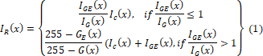

Where, IR(x) represents the hue preservation enhanced color image, IG(x) is the grayscale image of the input underwater image generated by the underwater image grayscale transformer stage, IGE(x) is the output of the grayscale image detail enhancement stage, IC(x) is the color restored underwater image from the underwater image color restoration stage and 𝑥 denotes the positions of pixels on the image.

##### RESULT ANALYSIS

In this section, hue preservation based high efficiency under water image correlation and enhancement using deep learning technique is implemented using Matlab. The implementation process is as follows: Step - 1: Open Matlab. The Fig. 2 shows the home page of Matlab.

Step - 2 : Login to matlab page. The Fig. 3 shows the user account page.

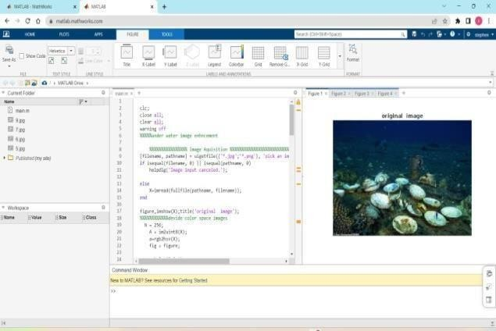

**Fig. 2: Matlab Home page**

**Fig. 5: Original Image**



**Fig. 3: MatLab User account page**

Step -3: Upload the code. Step - 4: Select an image as an input. Step -5 : Click on the option performance under the training plots when the dialog box appears. Step -6

: After clicking on performance 3 output graphs are shown which shows the enhancement of the image. The fig. 4 shows the performance graph output.

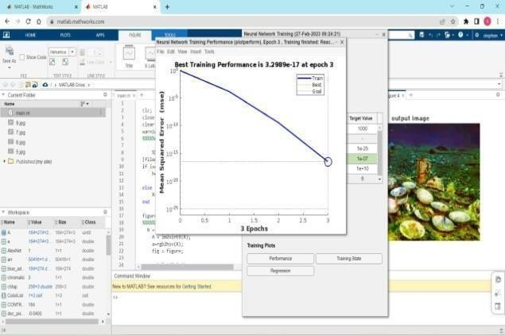

**Fig. 4: Performance graph output**

The Fig. 5 shows the original image.

The Fig. 6 shows the Stages of enhancing the original image.

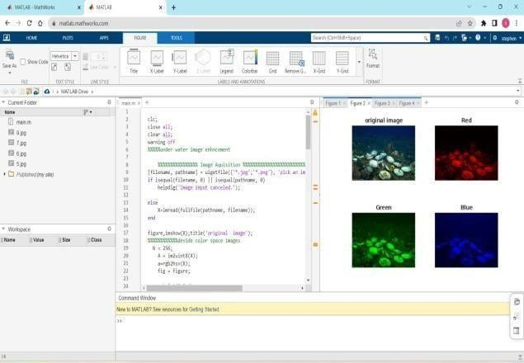

**Fig. 6: Stages of original image Enhancement**

The fig. 7 shows the enhanced image.

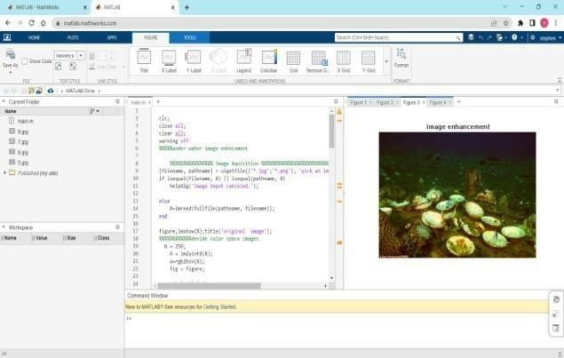

**Fig. 7: Enhanced Image**

The fig. 8 shows the output image.

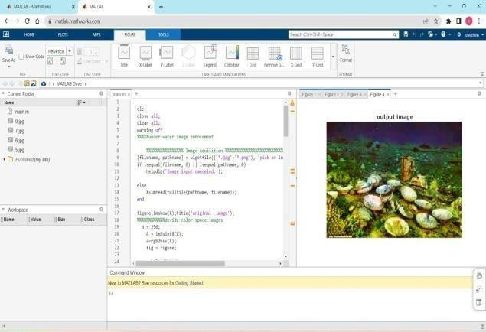

**Fig. 8: Output Image**

Hence this approach has effectively enhanced the underground image. In this manner one can enhance the underground image very effectively.

##### CONCLUSION

In this work, Hue preservation based high efficiency under water image correlation and enhancement using deep learning technique is presented. In this work, a CNN framework is used for underwater image color restoration. This method converts an input underwater image to the grayscale image by using CNN to estimate the grayscale coefficients. CNN is also used to restore the color of the input underwater image. To remove the noise in underwater environment and reserve the detail that may affect by CNN, a grayscale detail enhancement CNN is presented. At last, all phases are integrated by the hue preservation enhancement. The experimental results show that the proposed method achieved better underwater image restoration performance than other methods. In future, we aim to leverage the pre-trained convolutional neural networks on large image data for the appearance learning instead of training our convolutional appearance module from scratch. This would not only accelerate the training speed but also allows employing quite deeper architectures and abundant existing image data to improve the performance of the appearance learning.

##### ACKNOWLEDGEMENT

We thank CMR Technical Campus for supporting this paper titled “Hue Preservation based high efficiency under water image correlation and enhancement using Deep Learning Technique”, which provided good facilities and support to accomplish our work. Sincerely thank our Chairman, Director, Deans, Head Of the Department, Department Of Computer Science and Engineering, Guide and Teaching and Non- Teaching faculty members for giving valuable suggestions and guidance in every aspect of our work

##### REFERENCES

1. Aashi Singh Bhadouria, “Underwater Image Enhancement Techniques: An Exhaustive Study”, International Journal for Research in Applied Science & Engineering Technology (IJRASET**)**, ISSN: 2321-9653; Volume 10 Issue II Feb 2022.
2. Xinjie Li, Guojia Hou, Kunqian Li, Zhe nkuan Pan, “Enhancing underwater image via adaptive color and contrast enhancement, and denoising”, [Engineering](https://www.sciencedirect.com/journal/engineering-applications-of-artificial-intelligence) [Applications of Artificial Intelligence,](https://www.sciencedirect.com/journal/engineering-applications-of-artificial-intelligence)

[Volume 111](https://www.sciencedirect.com/journal/engineering-applications-of-artificial-intelligence/vol/111/suppl/C), May 2022, 104759

1. Daqi Zhu, Zhiqiang Liu, Youmin Zhang, “Underwater image enhancement based on colour correction and fusion”, IET Image Processing, 2021; 15:2591– 2603, DOI: 10.1049/ipr2.12247.
2. Yifan Huang, Manyu Liu, Fei Yuan, “Color correction and restoration based on multi-scale recursive network for underwater optical image”, Signal Processing: Image Communication 93 (2021) 116174, Elsevier, doi:10.1016/j.image.2021.116174
3. Monika Mathur, Nidhi Goel, “Enhancement of Non-Uniformly Illuminated Underwater Images”, International Journal of Pattern Recognition and Artificial Intelligence, doi: 10.1142/S0218001421540082
4. 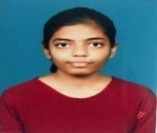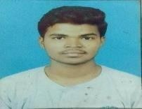Herng-Hua Chang, Po-Fang Chen, Jun- Kai Guo and Chia-Chi Sung, “A self- adaptive single underwater image restoration algorithm for improving graphic quality”, EURASIP Journal on Image and Video Processing, (2020) 2020:41, doi:10.1186/s13640-020-00528- 0
5. Zeba Patel, Chaitra Desai, Ramesh Ashok Tabib, Medha Bhat, Ujwala Patil, Uma Mudengudi, “ Framework for under water image enhancement”, Third International Conference on Computing and Network Communications (CoCoNet’19), Procedia Computer Science 171 (2020) 491–497.
6. Chonyi Li, Jichang Guo, and Chunle Guo, “Emerging from Water: Underwater Image color correction based on weakly supervised color transfer ", IEEE Signal processing letters, Vol.25, No.3, March 2018
7. Krishnapriya T S, Dr. Nissan Kunju, “Underwater Image Processing using Hybrid Techniques”, **:** [2019 1st](https://ieeexplore.ieee.org/xpl/conhome/8736880/proceeding) [International Conference on Innovations in](https://ieeexplore.ieee.org/xpl/conhome/8736880/proceeding) [Information and Communication](https://ieeexplore.ieee.org/xpl/conhome/8736880/proceeding) [Technology (ICIICT),](https://ieeexplore.ieee.org/xpl/conhome/8736880/proceeding)

DOI: [10.1109/ICIICT1.2019.8741468](https://doi.org/10.1109/ICIICT1.2019.8741468)

1. Jie Li, Katherine A. Skinner, Ryan M. Eustice, and Mathew Johnson-Roberson, “WaterGAN: Unsupervised Generative Network to enable Real-Time color correction of Monocular Underwater Images”, IEEE Robotics and Automation letters, Vol.3, No.1, January 2018.
2. K. Panetta, Chen Gao, and Sos Again, "Human-visual-system inspired Underwater Image Quality Measures ", IEEE Journal of Oceanic Engineering, Vol.41, No.3, July 2016

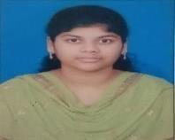Bhupathiraju Geetha Supriya is currently pursuing B. Tech final year in the stream of Computer Science and Engineering in CMR Technical Campus, Medchal, Hyderabad, Telangana, India.

Yogitha Potlapally is currently pursuing B. Tech final year in the stream of Computer Science and Engineering in CMR Technical Campus, Medchal, Hyderabad, Telangana, India.

Katepogu Stephenkumar is currently pursuing B. Tech final year in the stream of Computer Science and Engineering in CMR Technical Campus, Medchal, Hyderabad, Telangana, India.

Mr. Jonnadula Narasimharao is currently working as an Assistant Professor in the Department of Computer Science and Engineering, CMR Technical Campus, Medchal, Hyderabad. He obtained his Bachelor Degree in B.E – Computer Science and Engineering from DMI College of Engineering, Anna University and Master’s Degree in

M. Tech – Computer Science and Engineering from TRR Engineering College , JNTU Hyderabad. He is Pursuing his doctorate in the field of Image Processing at Madhav University, Pindwara, Rajastan. His areas of Specialization include Image Processing, Deep Learning, Machine Learning, IOT, Data Mining and Networks. He has more than 15 years of Teaching Experience. He has Published his Research work in reputed international journals with high impact factor in Elsevier, Springer, web of science, Scopus. He has certified in NPTEL, Coursera courses. Added to that He has also presented papers in both international and national conferences. He has an Indian patent in his expertise areas from Computer Science and Engineering field. He is a life member of the professional body - Indian Society for Technical Education (ISTE).

**CERTIFICATES**

